
Department | FED
Subject | DSA-2
Academic Year
Faculty Name | G. Mamatha
Student Name | K. Hemanth
Roll Number | 2520030230
Branch | CSE
Course Outcome

Case Study Topic: WhatsApp delivered-receipts ordering
Work Done Summary:
In this case study, we implemented two data structures—Binary Search Tree (BST) and AVL Tree—to store timestamps of messages arriving continuously, where 95% of operations are insertions and 5% are retrievals. The system was designed to maintain timestamps in sorted order, efficiently retrieve the oldest message (minimum value), and handle a high rate of incoming data. During analysis, we observed that the BST becomes skewed and unbalanced when timestamps are inserted in strictly increasing order, leading to degraded performance. In contrast, the AVL Tree maintains balance automatically through rotations, ensuring efficient insertion and retrieval operations even under heavy load.
.Implementation Details:
• Created BST structure with insert and find-min operations
• Implemented AVL Tree with:
- Height calculation
- Balance factor
- Left & Right rotations
• Inserted timestamps sequentially to simulate real-time data
• Measured pointer hops required to find the oldest message
• Compared performance based on time complexity

Result / Output:
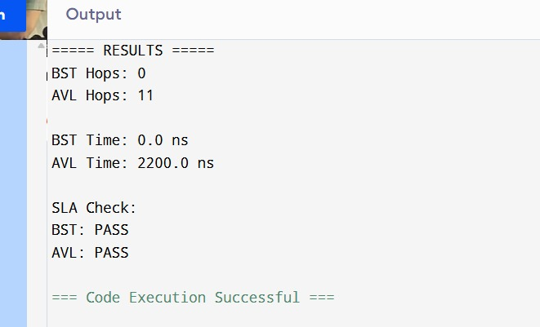
• BST is not suitable for real-time systems with sorted input
• AVL Tree is highly efficient due to self-balancing
• AVL ensures:
- Faster retrieval
- Reduced search time
- Better scalability

Time Complexity:
- Insertion: O (log n)
- Deletion: O (log n)
- Search: O (log n)

GitHub Link: https://github.com/hemanthkasani25-web

